**Assignment –5**

**Relational and Logical Operators**.

**1)** Write a query that will give you all orders for more than Rs. 1,000.

**Answer –**

**select * from orders where Amt > 1000;**

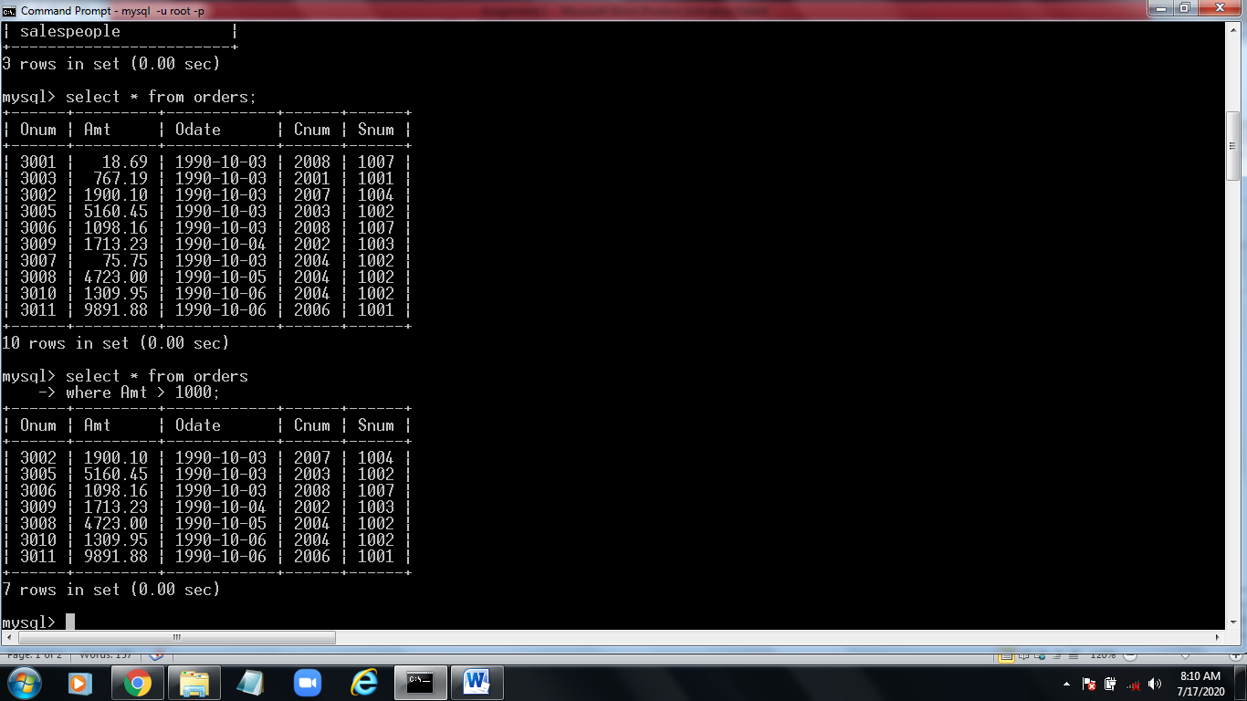

**2)** Write a query that will give you the names and cities of all salespeople in

London with a commission above .10.

**Answer -**

**select Sname,City from salespeople where City=’London’ and comma > .10;**

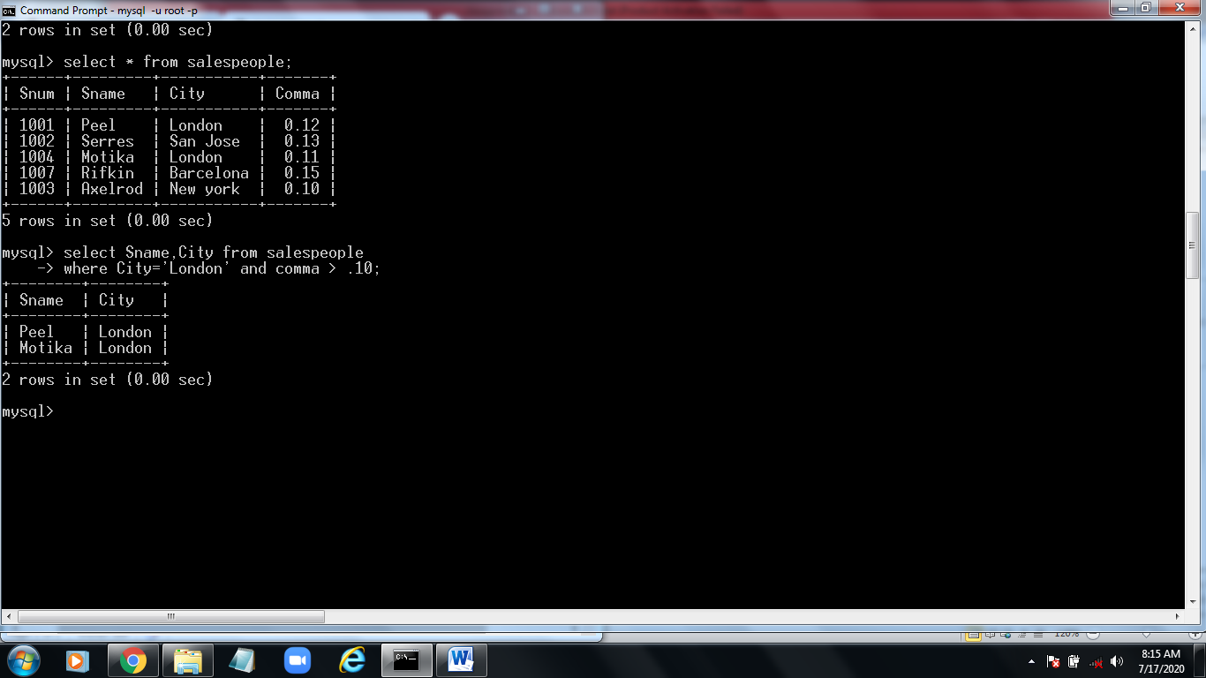

**3)** Write a query on the Customers table whose output will exclude all customers

with a rating <= 100, unless they are located in Rome.

**Answer -**

**select * from customers where Rating <= 100 and City!=’Rome’;**

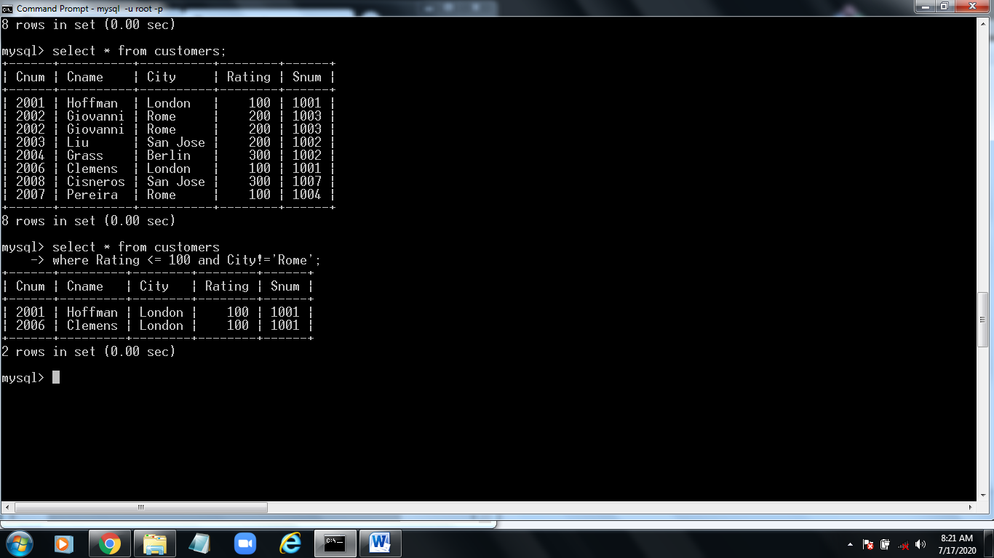

**4)** What will be the output from the following query?

Select * from Orders

where (amt < 1000 OR

NOT (odate = ‘1990-10-03’

AND cnum > 2003));

**Answer -**

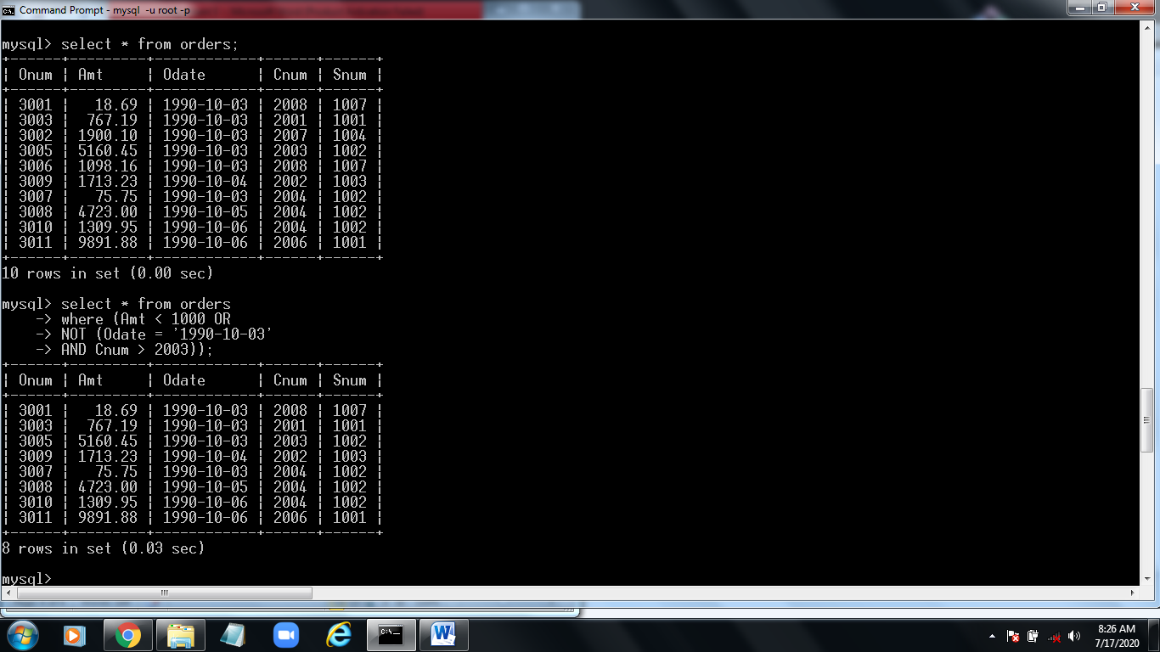

**5)** What will be the output of the following query?

Select * from Orders

where NOT ((odate = ‘1990-10-03’ OR snum

>1006) AND amt >= 1500);

**Answer -**

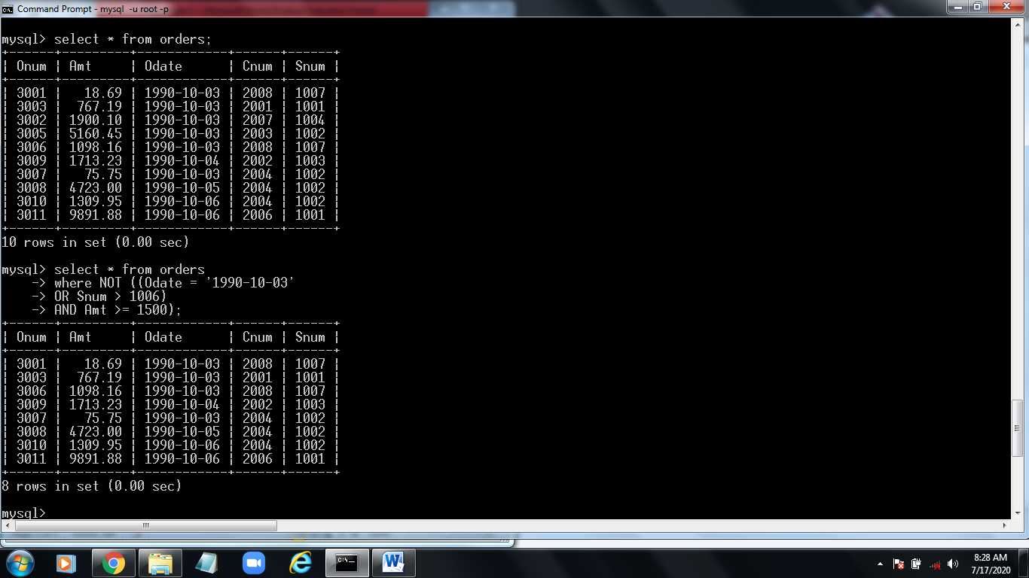

**6)** What is a simpler way to write this query?

Select snum, sname, city, comm From Salespeople

where (comm > .12 OR comm <.14);

**Answer -**

